Department of Computer and Software Engineering
SE: Machine Learning

Course Instructor: | Date:
Day: | Semester:

Lab 12: Model Deployment using Flask & Package Management

Lab Title | CLO | BT | PLO | Weightage
Model Deployment using Flask
REST APIs, Docker & uv

Name | Roll Number | Report /10 | Viva /5 | Total /15
Zunaira Abdul Aziz | BSSE23058

Checked on:
Signature:

Objectives
- Convert an existing API from FastAPI to Flask
- Understand differences between API frameworks
- Deploy a trained model through a web interface and containerize it
- Utilize uv to manage modern Python environments and resolve version conflicts

Problem Statement
In the previous lab, you built a machine learning pipeline, tracked experiments using MLflow, serialized the trained model, and deployed it using a FastAPI-based REST API.
In real-world systems, different frameworks may be used depending on project require-ments. Flask is a lightweight and widely used framework for building simple web appli-cations and APIs. Furthermore, managing dependencies for complex ML packages (like MediaPipe for computer vision) often leads to version conflicts on newer Python releases.
In this lab, you will convert the FastAPI deployment into a Flask application. Follow-ing this, you will explore environment and version management using uv to resolve a simulated dependency conflict.
You are required to demonstrate the working system through screenshots of:
- The running Flask application and web interfaces
- Terminal outputs demonstrating dependency errors and their resolution

Part A: Understanding Existing API
Task 1: Analyze FastAPI Implementation
Review your Lab 11 FastAPI code and identify:
- How the model is loaded
The model is loaded globally upon script execution to prevent redundant disk reads.
Method: Uses joblib.load("model.joblib") within a try-except block.
Handling: If the file is missing, model is set to None, which triggers a 503 Service Unavailable error during prediction attempts.
- How input is received
Data enters the system via a POST request to the /predict endpoint.
Format: It expects a JSON object parsed as a Python dict containing a features key.
Validation: The code manually verifies the presence of the key and raises a 422 Unprocessable Entity error if it's missing.
- How predictions are returned
The API processes the input and returns a structured JSON response.
Transformation: The input list is converted to a NumPy array and reshaped to (1, -1) to satisfy the model's requirement for 2D input.
Output: The scikit-learn prediction is cast to a standard Python int to ensure JSON compatibility and returned as {"prediction": <value>}.

Part B: Flask Setup
Task 2: Create Flask Application
Create a Flask application with:
- A home route (/)
- A prediction route (/predict)

from flask import Flask, request, jsonify
import joblib
import numpy as np

app = Flask(__name__)

try:
model = joblib.load("model.joblib")
except:
model = None

@app.route("/", methods=["GET"])
def home():
return jsonify({"message": "ML Model API (Flask) is running"})

@app.route("/predict", methods=["POST"])
def predict():
# Input Reception
data = request.get_json()

if not data or "features" not in data:
return jsonify({"error": "Missing 'features' key in request body"}), 422

if model is None:
return jsonify({"error": "Model not loaded"}), 503

try:
# Prediction and Return
features = np.array(data["features"]).reshape(1, -1)
prediction = model.predict(features)
return jsonify({"prediction": int(prediction[0])})
except Exception as e:
return jsonify({"error": f"Inference error: {str(e)}"}), 400

if __name__ == "__main__":
app.run(debug=True)

Part C: Model Integration
Task 3: Load and Use Model
Load the serialized model from Lab 11 and use it to make predictions. Ensure:
- Correct input format
- Proper handling of numerical features
from flask import Flask, request, jsonify
import joblib
import numpy as np

app = Flask(__name__)

try:
model = joblib.load("model.joblib")
except:
model = None

@app.route("/predict", methods=["POST"])
def predict():
data = request.get_json()

if not data or "features" not in data:
return jsonify({"error": "Missing 'features' key in request body"}), 422

if model is None:
return jsonify({"error": "Model not loaded"}), 503

try:
# Prediction and Return
features = np.array(data["features"]).reshape(1, -1)
prediction = model.predict(features)
return jsonify({"prediction": int(prediction[0])})
except Exception as e:
return jsonify({"error": f"Inference error: {str(e)}"}), 400

Part D: Web Interface
Task 4: Create Input Form
Create a simple HTML form to take input features from the user. Display prediction results on the webpage.
<!DOCTYPE html>
<html>
<head>
<title>ML Lab 12 - BSSE23058</title>
</head>
<body>
<h2>Enter Feature Values</h2>
<form method="POST">
<input type="number" step="any" name="f1" placeholder="Age" required><br><br>
<input type="number" step="any" name="f2" placeholder="Income" required><br><br>
<input type="number" step="any" name="f3" placeholder="Hour" required><br><br>
<input type="number" step="any" name="f4" placeholder="Leak Feature" required><br><br>
<button type="submit">Predict</button>
</form>

{% if prediction is not none %}
<h3>Result: {{ "Positive (1)" if prediction == 1 else "Negative (0)" }}</h3>
{% endif %}
</body>
</html>
Task 5: Demonstration
Run the Flask application and capture screenshots of:
- Running server (terminal)
- Input form in browser
- Prediction output

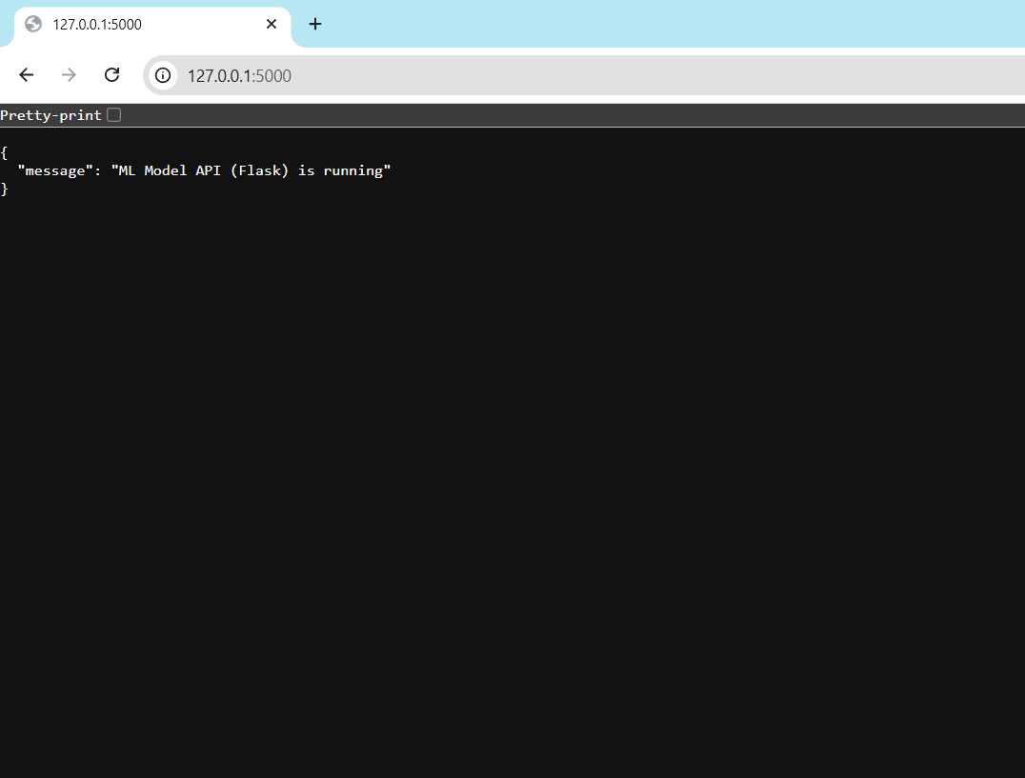

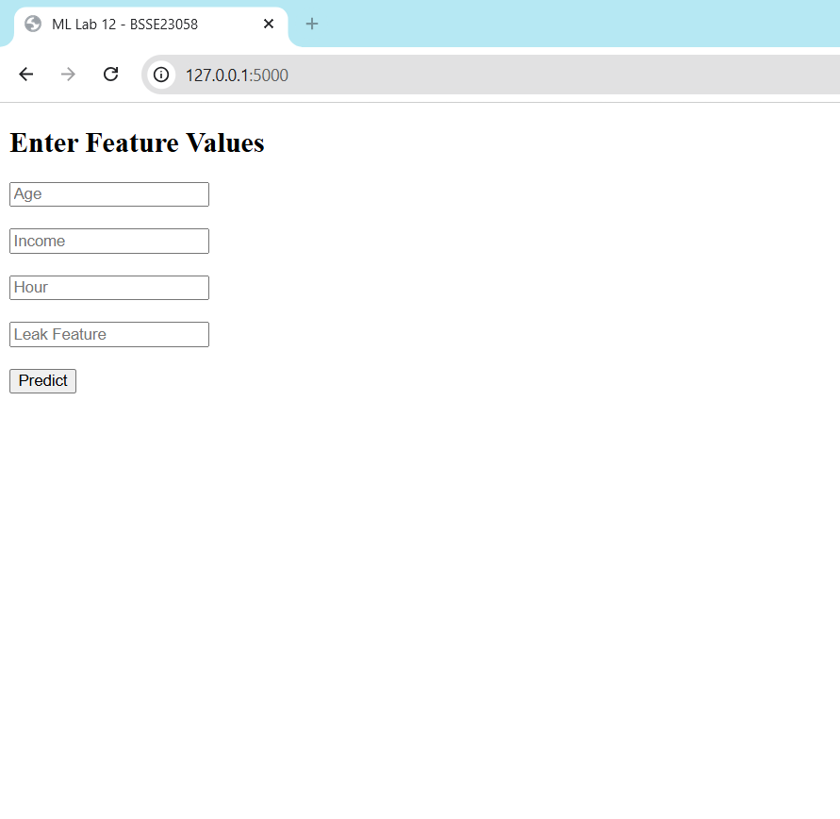
With values: 25, 5000, 14, 0.5
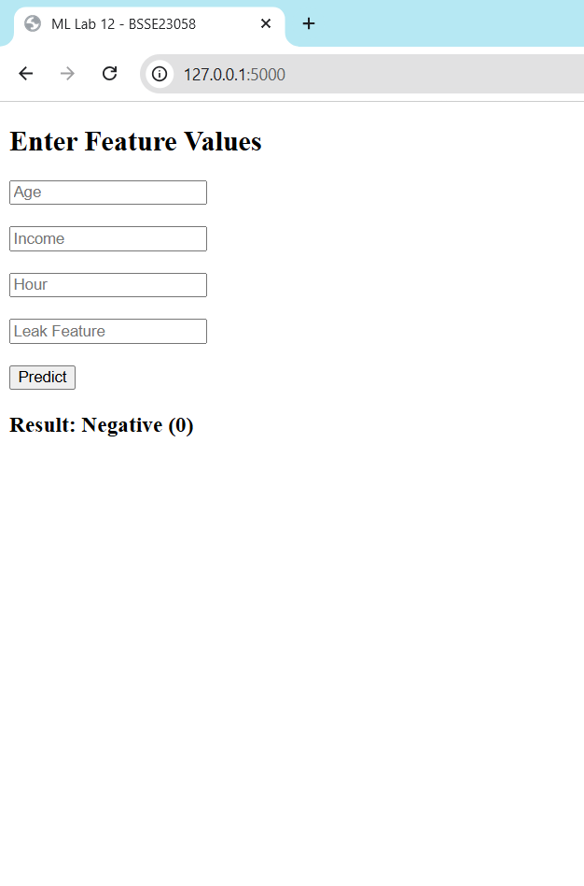

Part E: Testing and Screenshots
Task 6: Create Dockerfile
Create a Dockerfile for your Flask application. Ensure:
- Base image uses Python
- Application dependencies are installed
- Flask app runs on port 5000
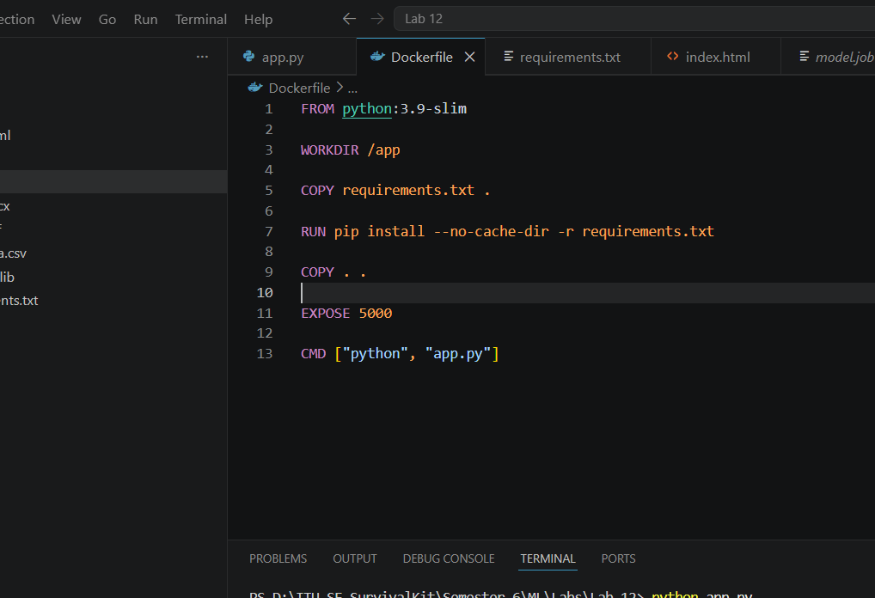

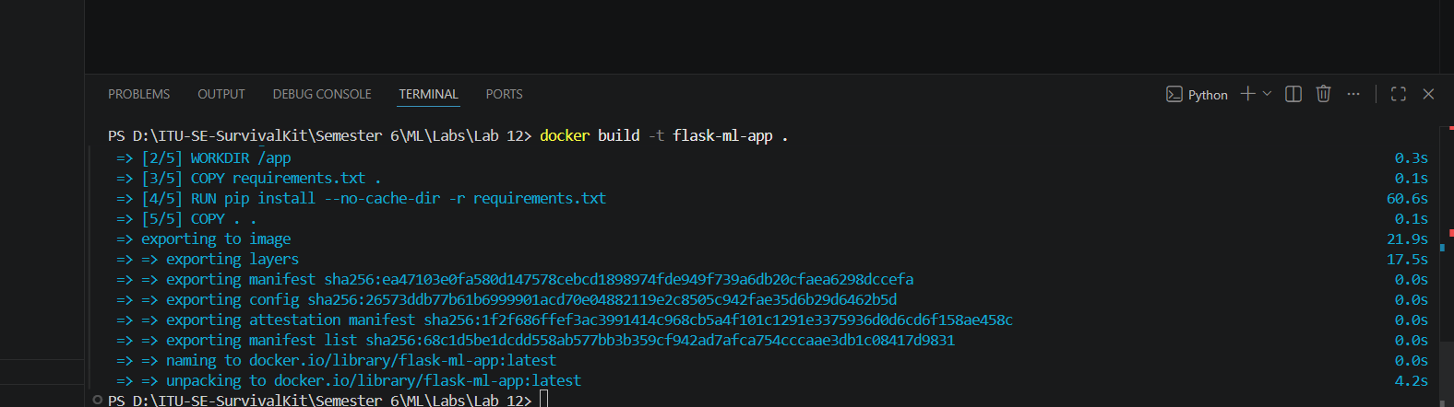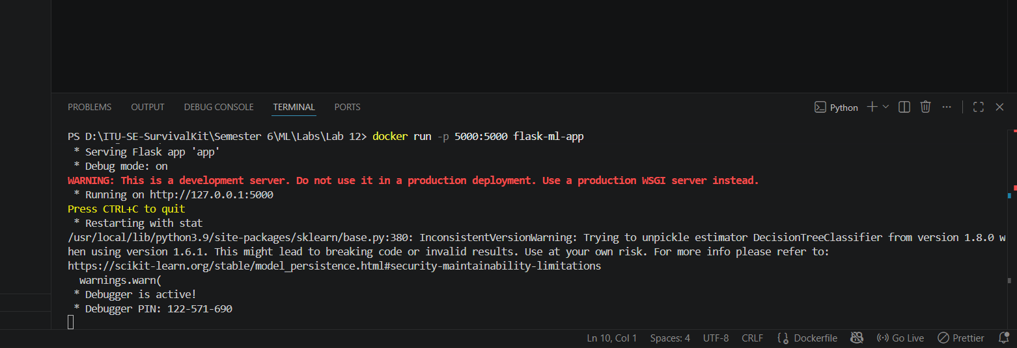

Part F: Containerization using Docker
Task 7: Build and Run Docker Image Build the Docker image and run it locally. Verify:

- Application runs inside container
- API is accessible via browser
Screenshot Required:
- Docker build output
- Running container and browser output
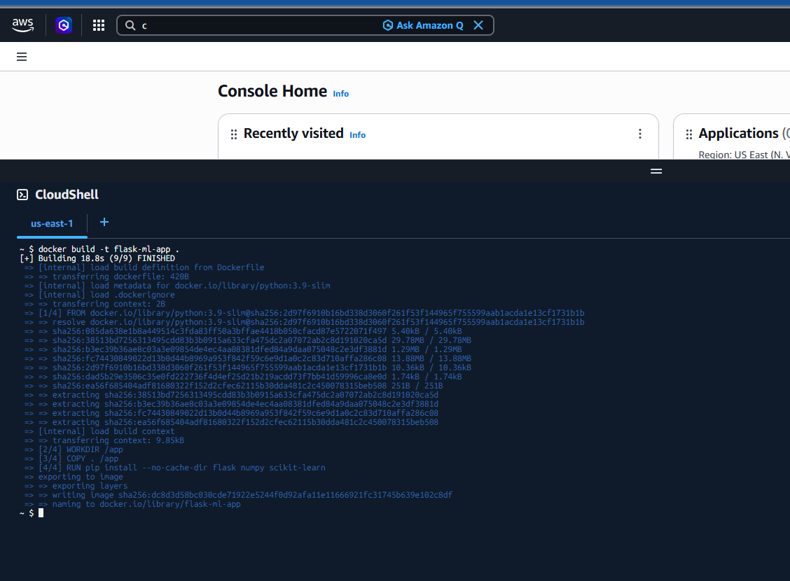
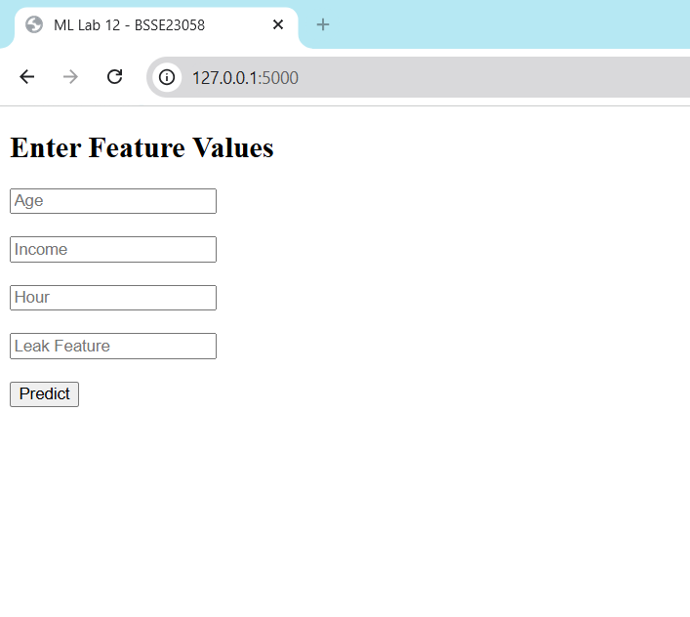

Part G: AWS ECR (Elastic Container Registry)
Task 8: Create ECR Repository
Create a repository in AWS ECR.
Login to ECR using AWS CLI and authenticate Docker.
Task 9: Push Docker Image to ECR Tag and push your Docker image to ECR. Screenshot Required:
- Successful image push
- ECR repository showing uploaded image

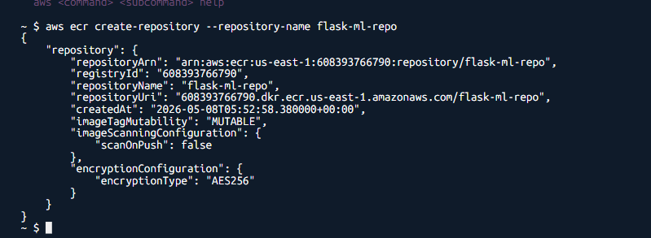

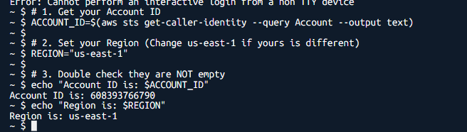

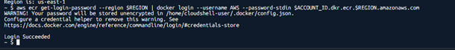

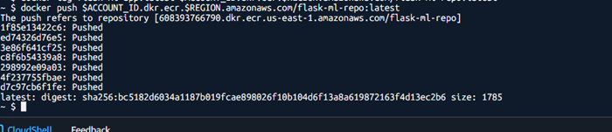

Part H: Deployment using Elastic Beanstalk
Task 10: Launch Environment
Using AWS CloudShell or local CLI:
- Initialize Elastic Beanstalk application
- Configure environment (Docker platform)
- Deploy application using ECR image
Task 11: Verify Deployment
Access the deployed application via public URL. Verify:
- Flask app is running
- Predictions are working
Screenshot Required:
- Elastic Beanstalk dashboard
- Live application URL in browser
- Prediction output
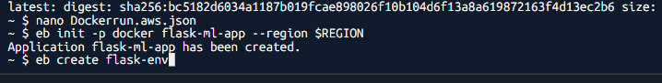
{
"AWSEBDockerrunVersion": "1",
"Image": {
"Name": "608393766790.dkr.ecr.us-east-1.amazonaws.com/flask-ml-repo:latest",
"Update": "true"
},
"Ports": [
{
"ContainerPort": 5000
}
]
}

